Installation guide

BillMacros helps with the formatting of Excel bills in the AEC industry. Refer to the “Quick guide”.

# Contact information

Kobus Burger

+27 83 228 9674

[kobusgburger@gmail.com](mailto:kobusgburger@gmail.com)

# Download & run

Download “setup.exe” from<https://kbeng.co.za/billmacros/setup.exe>**”** and run “setup.exe”

Browser may say it is not trusted because it is an exe file. Typically select “Open”, “Keep”, “Run” or other confirmation so that the file is downloaded and executed. If it does not open automatically Double click or Open “setup.exe” (probably in the download folder).

## Firefox message

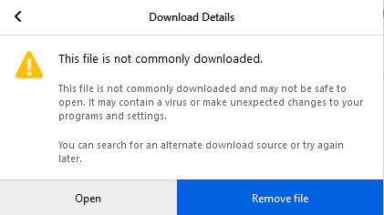

## Chrome message

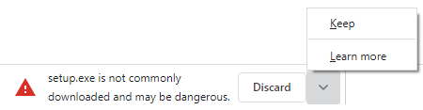

## Edge

Edge does not give warnings





# Installation

First install the certificate (see below). This is only required once.

The “Microsoft Office Customization Installer” may warn about harm to your computer. Click “Install” and then “Close”.

BillMacros are now installed and the “KB” tab should show in Excel (you may need to restart Excel).

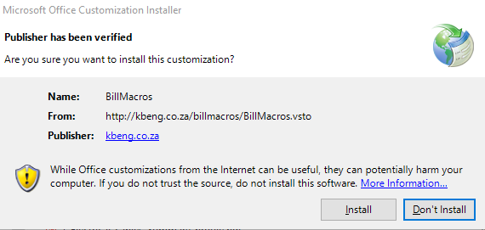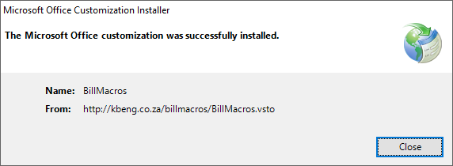

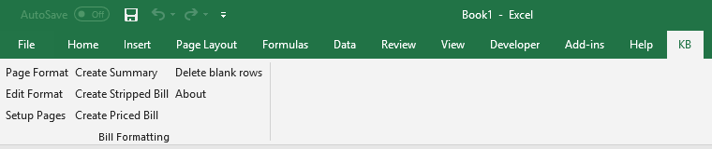

## Anti-virus software

Windows Defender (or another anti-virus system) may warn that the publisher is unknown if the certificate is not installed. Click “More info” and then “run anyway”. It states unknown publisher because the certificate is not in the trusted folder (see above).

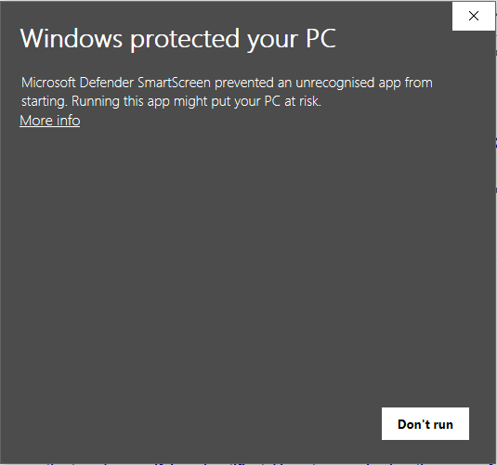 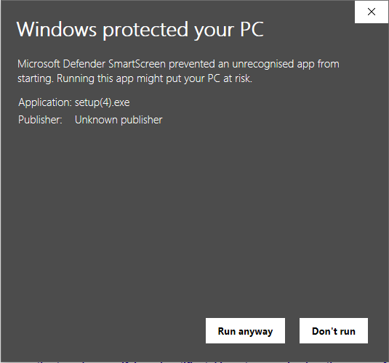

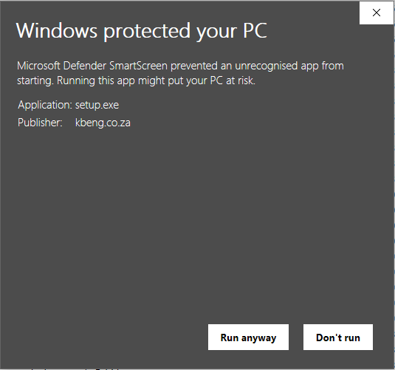

# Install certificate

The certificate needs to be installed in the “Trusted Root Certification Authorities” folder to avoid “unknown publisher” warnings. This is only required once.

Follow the following steps to install the certificate.

1. Right click “setup.exe” and click “Properties”. It will state “This file came from another computer and might be blocked to help protect this computer”.
2. Select the “Digital Signatures” tab. It should list “kbeng.co.za”.
3. Click “Details” then “View Certificate” and then “Install Certificate”.
4. “Current User” or “Local Machine” is good. Select “Place all certificates in the following store”. Click “Browse” and select “Trusted Root Certification Authorities”. Click “Finish”
5. Click “Yes” on the “security Warning” window. Click “OK” on the confirmation window.
6. Close all the windows by clicking “OK”.

